Chapter 8, Problem 75.

Obtain the dual of the circuit in Fig. 8.119.

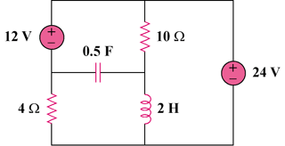

Figure 8.119
For Prob. 8.75.

